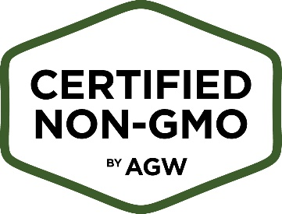
Certified Non-GMO by AGW Testing Protocol Template

Operator Name: ________________________ Farm Name: ___________________________
Laboratory Used* (if applicable): ____________________________
Non-GMO Species/Crops/Products:

FEEDS RISK RATING: Low/Moderate/High MITIGATION
Directions: List ALL feeds, including seasonal feeds, supplements and vitamins | Directions: Risk Rate each feed type as defined on p. 6 of the CNGMO Standards | Directions: Describe the actions taken to mitigate risk
Example: Cottonseed Meal | Example: High Risk | Example: Each lot of high and moderate risk feeds are tested and verified before being fed.

Testing Plan (Describe your general testing protocol (e.g. frequency of testing, method of testing, laboratory used, etc.). You may use the chart below to outline specific testing methods)
Feed Testing Method (17.4.3) Frequency (17.4.2, 17.4.3) Threshold Limit (17.4.9)
Example: Alfalfa | Example: Quantitative PCR | Example: Tested every lot | Example: 0.09%

Corrective Action Plan (Describe the corrective actions taken if a sample tests above the threshold limit)

Annual Review Date:_________________________ Signature:______________________________

Please Note
The following information will be reviewed on an annual basis, or as needed. These records should be kept on file and made available to AGW, as requested:
- Test Dates
- Test Results
- Non-GMO documentation for each feed type
* AGW is currently contracted with FoodChain ID. This contract ensures a minimum of 10% discount of all GMO testing services, as well as tax exemption, to all AGW operators. To utilize this discount, AGW operators must notify FoodChain ID of their association with AGW prior to testing. AGW operators are not required to use FoodChain ID.

